   | 
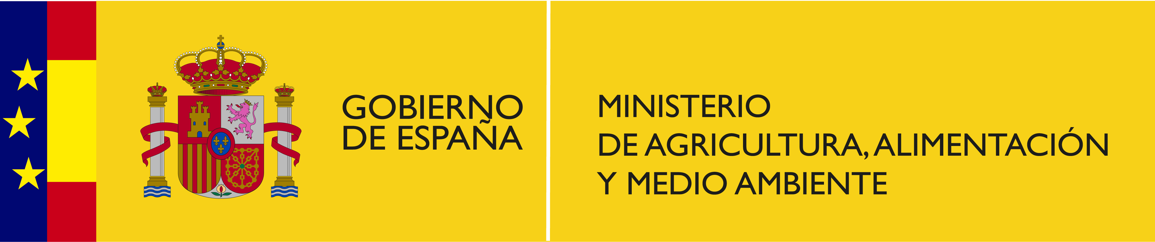


Study tour for the Countries Participating at the “ Global Project on the Implementation of Pollutant Release and Transfer Registers (PRTR) as a tool for Persistent Organic Pollutants (POP) reporting, dissemination and awareness raising”

Provisional Agenda

30 November 2015
Madrid, Spain
Study Tour on Pollutant Release and Transfer Register in Spain

09.00 – 09.30 Background on PRTR in Spain
09.30 – 10.30 Online demonstration of PRTR system: main characteristics
- Reporting form, modalities and frequency
- List of chemicals
- Access to information and report development
- Standardization of data
- Annual cost and resources needed
10.30-10.45 Coffee Break
10.45 – 13.00 Ask the expert: Stakeholders’ participation on PRTR development
Case studies:
- NGO and Academia participation
- Industry participation
- Government role
13.00 – 14.00 Lunch
14.00 – 14.30 Reporting point sources of air emissions by industry
14.30 – 15.00 Reporting industrial waste by industry
15.00 – 15.30 Estimation of non-point sources
15.30 – 16.00 Reporting hazardous wastes
16.00 - 16.45 Open discussion: challenges and opportunities
16.45 - 17.00 Adjourn

