Global Project on the Implementation of Pollutant Release and Transfer Registers (PRTR) as a tool for Persistent Organic Pollutants (POP) reporting, dissemination and awareness raising for Belarus, Cambodia, Ecuador, Kazakhstan, Moldova and Peru
First Steering Committee Meeting and Inception Workshop
Madrid, 26-28 November 2015
Project overview
- The project document sets out the objectives of the project as follows:
- To improve access and accuracy of environmental data on POPs and other priority chemicals in 6 countries, and to enhance awareness and public participation on environmental matters, through implementation of fully operational national PRTRs;
- To implement a PRTR in the six participating countries, namely Belarus, Cambodia, Ecuador, Kazakhstan, Moldova and Peru.
- The structure of the project is shown in Figure 1 and comprises five principal components:
Component 1: Project baseline strengthened and national needs identified;
Component 2: Build capacity to implement PRTRs as a National POPs Reporting System;
Component 3: Standardization and comparison of PRTR data;
Component 4: Access to PRTR data and public information;
Component 5: Lessons learned and replication
- Component 1 includes both national and global activities. Under the national activities, the six participating countries will update their PRTR National Executive Proposals. These proposals provide information on PRTR technical design (database design and structure, stakeholder mechanisms and coordination, list of chemicals to be considered, reporting formats, etc). Participating countries will also work on the development of a draft regulatory framework for national adoption. UNITAR will include in the PRTR Platform all documents related to design and implementation of PRTRs, including those from OECD, UNEP, UNITAR, etc.
- Component 2 also includes national and global activities. As part of the global activities, UNITAR will develop training modules to support the development of national PRTRs. National activities under this project component include training for specific key sectors, national guidance on estimation techniques and conducting the pilots on PRTR reporting.
- Component 3 includes global activities and will be based on the results of component 2. A study on standardization of data will be develop and will assist to obtain consistent data from all participating countries. Additionally, a guide for PRTR implementation and POPs reporting will focus on common elements to be considered when developing a PRTR system. Lastly, an analysis of the results of the pilot will be performed; this is particularly useful to improve in certain areas of PRTR development and to identify common areas or work
- Component 4 includes national activities, namely the development and implementation of national strategies for public access to environmental and PRTR related information.
- Component 5 includes the development of a lessons learned report which includes recommendations and analysis on PRTR development in countries.
- The Monitoring and Evaluation component of the project has been included in Project Component 5. For practical reasons, it will be presented separately during the workshop.
Country components of the project
- The project includes activities to be carried out by participating countries with the technical support of UNITAR. This section further explain those activities to be lead and implemented by participating countries.
- The project is based on the results obtained from the first GEF UNEP/UNITAR project (2009-2012). Cambodia, Ecuador, Kazakhstan and Peru participated in the first PRTR project, which focused on PRTR design. The main output was a PRTR executive proposal to be submitted to cabinet. Belarus and Moldova did not participate in the above mentioned project. However it is understood that both countries have some work undertaken on PRTRs. UNITAR will provide special support to those countries.
- Project component 1 includes the following activities to be developed by national project teams:
Activity 1.2 Update of national executive proposals. These proposals provide information on PRTR technical design (database design and structure, stakeholder mechanisms and coordination, list of chemicals to be considered, reporting formats, etc). In the last years a number of changes have occurred in the global economy and in the field of chemicals management. Since 2009 the list of POPs has been modified to include 13 new chemicals and the Minamata Convention on Mercury is now open for ratification. All of these changes trigger a revision of the PRTR implementation plan or so called PRTR executive proposals.
Activity 1.3 Draft national PRTR legal framework. Countries that have participated in the first GEF UNEP/UNITAR project have drafted PRTR legislation. This project will assist them to update the drafted legislation, which will be part of the National PRTR Executive Proposal.
- Project component 2 includes three main activities to be carried out by countries.
Activity 2.2 Develop and implement national training for key sectors. National training will take place by sector, including key productive sectors at the national level and key national stakeholders. Productive sectors will be trained on how to report, what parameters are considered for reporting, international experiences, etc. NGOs might be more concerned with access to information issues, and governments on coordination and management of the PRTR system. Each participating country will identify and address the needs for training for each sector involved on PRTR development and implementation.
Activity 2.3 Develop national guides on estimation techniques. A lesson learned from past experiences is the need to develop local or regional emission factors, the emission factors provided by developed countries are for reference and to assist with an initial estimation. UNITAR will assist countries in developing these local emission factors. As it is the case of the Dioxins and Furans inventory, emission factors should reflect national and regional realities, this project will assist countries to develop regional, and if possible, local emission factors.
Activity 2.4 Conduct pilots using PRTRs to report on POPs. The pilot conducted under this project will be used as a basis to prepare the national report on POPs to the BRS Secretariat.
- Project component 3 does not include activities at the national level
- Project component 4 includes two main activities to be carried out by national project teams
Activity 4.1 Develop national strategies for public access to environmental information and PRTRs and Activity 4.2 Implement national strategies for public access to environmental information and PRTRs. This project will advocate for full participation of the civil society. A key aspect of civil society participation is to promote active participation during PRTR implementation through making meaningful and appropriate use of PRTR information, relevant to the national situation and needs.
- Project component 5 does not include activities at the national level.
Global or “umbrella” components of the project
- The project includes activities to be carried out by the Executing Agency for this project (UNITAR). This section provides further details on those activities to be lead and implemented by UNITAR
- Project Component 1 includes PRTR materials revised and made available to participating countries.
Activity 1.1 Review existing PRTR related materials. UNITAR will categorize these materials according to their relevance and subject on PRTR development and will provide access to them to participating countries.
- Project component 2 includes one activity to be implemented by UNITAR.
Activity 2.1 Develop and implement training modules for global use. UNITAR will develop standard training modules and materials to be used by any interested country on key topics: a) online reporting systems; b) legal implementation of PRTRs; c) release estimation techniques; d) Communication and interpretation of PRTR data; e) inclusion of POPs into PRTRs; f) PRTR standardization. Prior to the development of the above mentioned materials, UNITAR will consult with countries if these modules address their concerns related to PRTRs. Countries will also be requested to propose topics to be addressed by the training modules.
- Project component 3 includes three activities to be lead and implemented by UNITAR.
Activity 3.1 Collect and analyze materials on PRTR standardization. UNITAR will collect this material and make it available to all participating countries. In addition to it, a brief analysis on the utility and applicability of the materials will be performed.
Activity 3.2 Revise and finalize updated guidance on PRTR implementation and POPs reporting. During the first GEF UNEP/UNITAR project on PRTRs, guidance on PRTR implementation and development was developed for Chile. It was intended to be used by the Chilean national government to incorporate POPS into the PRTR systems. UNITAR will update this guidance document.
Activity 3.3 Analyze and compare PRTR data from pilots. An analysis of the results of the pilot will be performed; this is particularly useful to improve in certain areas of PRTR development and to identify common areas or work.
- Project component 4 does not include activities to be lead or implemented by UNITAR.
- Project component 5 includes the following activities to be implemented by UNITAR:
Activity 5.1, 5.2 and 5.3 Organize a global, mid-term and final workshop to analyze lessons learned. UNITAR will develop a final lessons learned report, which is to be disseminated to any country interested on PRTR development. The lessons learned report will draw upon surveys and dialogues carried out with countries. During the first GEF UNEP/UNITAR project on PRTRs, a lessons learned report was developed and will be considered as a basis for this project.
Project Workplan
- The project was approved by GEF in February 2014. Administrative processes and negotiations among the Implementing and Executing Agency caused considerable delays.
- The project is expected to be implemented in four years, as detailed in Table 1.
- Project component 1 is expected to last 10 months. Component 2 is expected to take 26 months. Component 3 is planned to take 16 months. Component 4 is expected to take 42 months and component 5 6 non continuous months.
- Project Overall Management and Supervision will take the whole duration of the project, 48 months.
Roles and responsibilities of Implementing and Executing Agencies and participating countries
- This project will be implemented by UNEP Chemicals and Waste Branch and executed by The United Nations Institute for Training and Research (UNITAR). UNITAR will execute, in partnership with local agencies, national activities in participating countries and will also supervise the project’s component on lessons learned and information exchange in participating countries.
- Every participating country will form a National Coordinating Team (NCT) which will be composed by different stakeholders from main sectors and will supervise and participate in the project. The overall execution and coordination of the activities at the national level in participating countries will be in charge of national agencies responsible for environmental management in the country. A PRTR Project Team (PT) will be established within the national executing agencies in every participating country and will be in charge of the execution and management of the project. It will report to the National Coordinating Team (NCT), to the Implementing Agency and to the POPs National Coordinating body.
- The national executing agencies will coordinate and will keep close contact with UNITAR in order to synchronize actions and to exchange information regularly. Participating countries will inform UNITAR regularly on changes to the original plan and on any other modification that might occur. Additionally, participating countries will report to UNITAR, as indicated in the Monitoring and Evaluation section.
- UNITAR, as Executing agency, provides institutional, technical, and legal support to governments and stakeholders to implement this project. UNITAR will report on progress made to UNEP and to the Project Steering Committee. More details to be provided in Monitoring and Evaluation section.
- UNEP, as Implementing Agency, will evaluate and assess progress made, will provide recommendations to project execution and will report to GEF Secretariat. A summary of the project structure and implementation arrangements is provided in Figure 2.

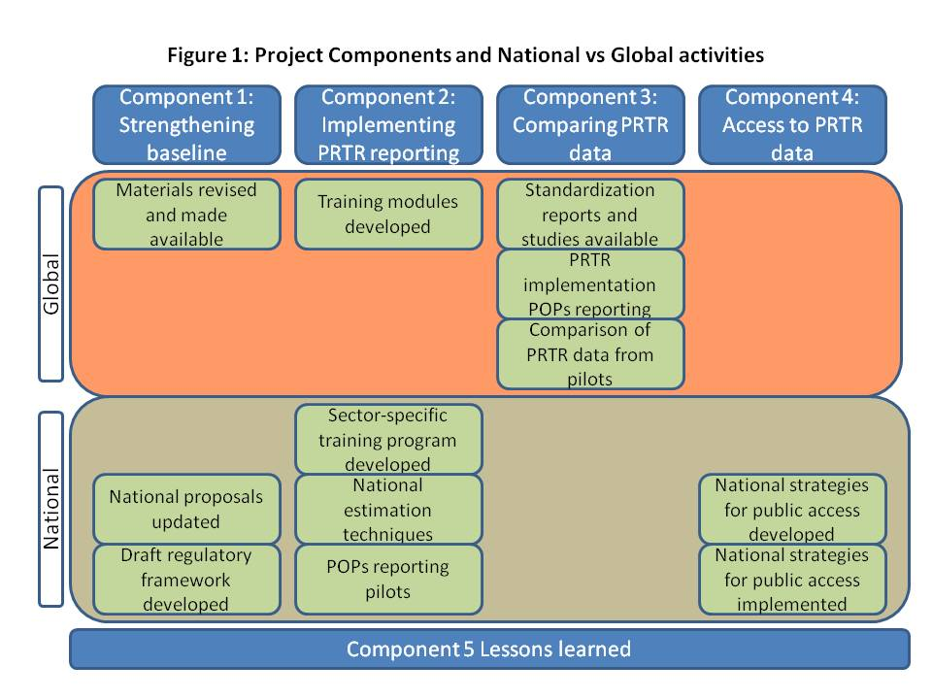
Figure 2: Project structure and implementation arrangements
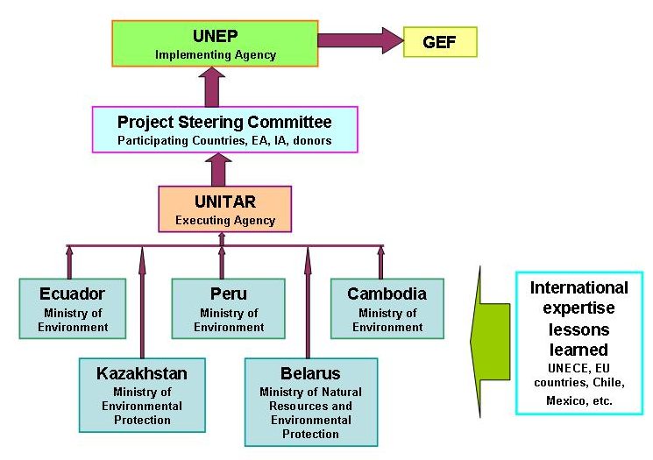

Table 1: Project workplan and timetable
Component | Activities | Year 1 |  |  |  |  |  |  | Year 2 |  |  |  |  |  |  | Year 3 |  |  |  |  |  | Year 4
1. Strengthening baseline and identification of national needs |  | 2 | 4 | 6 | 8 | 10 | 12 | 2 |  | 4 | 6 | 8 | 10 | 12 | 2 |  | 4 | 6 | 8 | 10 | 12 | 2 | 4 | 6 | 8 | 10 | 12
 | 1.1 Identify key actors and experts and review existing PRTR related materials
 | 1.3 Update national PRTR executive prop
 | 1.4 Draft National PRTR legal instruments
2. Capacity building activities towards the development of a PRTR for POPs reporting | 2.1 Develop and implement training modules for global use
 | 2.2 Develop and deploy national training for key sectors
 | 2.3 Develop national guides on estimation techniques
 | 2.4 Conduct pilots on using PRTRs to report POPs
3. Standardization and comparison of PRTR data | 3.1 Collect and analyse materials on standardisation
 | 3.2 Revise and finalize updated guidance on PRTR implementation and POPs reporting
 | 3.3 Analyse/compare PRTR data from pilots
4. Access to PRTR data and public information | 4.1 Develop national strategies for public access to environmental information and PRTRs
 | 4.2 Implement national strategies for public access to information
5. Lessons learned and replication | 5.1 Organise a global workshop to analyse lessons learned
 | 5.2 mid-term global meeting on lessons learned
 | 5.3 Final lessons learned workshop

