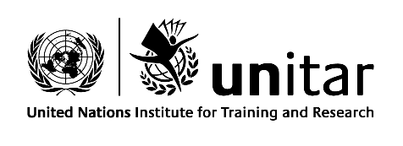
Terms of Reference
Mid-term Evaluation on the Implementation
of the 2018-2021 Strategic Framework

Background
- The United Nations Institute for Training and Research (UNITAR) is an important training arm of the United Nations, with the aim to increase the effectiveness of the United Nations in achieving its major objectives through training and research. UNITAR is guided by a four-year strategic framework which articulates the Institute’s vision, mission, core values and strategic objectives and enablers. The present framework, covering the period from 2018 to 2021, was approved by the Institute’s Board of Trustees in November 2017.

- UNITAR develops the individual, institutional and organizational capacity of countries and other United Nations stakeholders through high-quality learning solutions and related knowledge products and services to enhance decision-making and to support country-level action for overcoming global challenges. Learning outcomes are associated with about two-thirds of the Institute’s 600 some events organized annually, with a cumulative outreach to over 130,000 individuals, including 90,000 learners (2019 figures). Approximately three-quarters of beneficiaries from learning-related programming are from developing countries. UNITAR training covers various thematic areas, including activities to support the implementation of the 2030 Agenda for Sustainable Development; multilateral diplomacy; public finance and trade; health; environment, including climate change, environmental law and governance, and chemicals and waste management; peacekeeping, peacebuilding and conflict prevention; social development; and resilience and disaster risk reduction.

- Under its 2018–2021 strategic framework, the Institute’s programme of work is guided by the 2030 Agenda for Sustainable Development and the outcomes of other major conferences held in 2015, including the Third United Nations World Conference on Disaster Risk Reduction, held in Sendai, Japan, the United Nations Climate Change Conference, held in Paris, and the Third International Conference on Financing for Development, held in Addis Ababa. The Institute’s strategic direction is also inspired by the call of the Secretary-General, contained in his report on repositioning the United Nations development system (A/72/124–E/2018/3), for United Nations entities to be the best providers in their domain, to follow integrated approaches, to be responsive to the differentiated demands of Member States, to deliver as one in partnership with other United Nations entities and to be nimble and results-driven.

- The strategic framework structures the Institute’s objectives, programming and activities under the peace, people, planet and prosperity pillars of the 2030 Agenda, in addition to cross-cutting programme pillars on accelerating the implementation of the 2030 Agenda, multilateral diplomacy and optimizing the use of technologies for evidence-based decision-making. The framework places emphasis on reaching the furthest behind first by working to address the learning and broader capacity needs of stakeholders from countries in special situations, in addition to placing emphasis on women empowerment and gender equality. The framework also identifies the following key strategic enablers to support efforts to achieve the objectives: human capital and institutional partnerships; quality, learning and evaluation; strategic communication; and enhanced business processes. The Institute’s organizational structure is aligned with the strategy, with division directors leading the development of programming under the relevant thematic and cross-cutting pillars, as well as leading operations and strategic planning and performance. The strategic framework calls for a mid-term evaluation.
Purpose of the evaluation
- The purpose of the evaluation is to assess the relevance, coherence, effectiveness, efficiency and likelihood of impact from the first two years of implementation of the strategic framework and to provide evidence towards achieving the objectives and uncovering what works, why and under what circumstances; to identify any problems or challenges that the implementation has encountered; and to issue recommendations, if needed, and lessons to be learned. As a mid-term process-focused exercise, the evaluation’s purpose is intended to provide an opportunity for learning and improvement. The evaluation should not only assess the extent to which progress has been made, but also seek to answer the ‘why’ question by identifying factors contributing to (or inhibiting) successful delivery of the Institute’s results and to inform the remaining period of implementation of the strategic framework.
Scope of the evaluation
- The evaluation will cover the period from 1 January 2018 to 31 December 2019 (the first two years of the four-year framework) and focus on progress achieving the five strategic objectives, with particular attention on how the Institute’s learning function has helped Member States and other United Nations stakeholders achieve Goals/targets of the 2030 Agenda. While the evaluation’s scope covers the first two years and the five strategic objectives, the evaluation should maintain sufficient focus to deliver reasonably quick findings and conclusions, with actionable recommendations that are useful for the remaining period of the framework and help inform the subsequent strategy from 2022.
Evaluation criteria
- The evaluation will assess project performance using the following criteria: relevance, coherence effectiveness, efficiency, and likelihood of impact.

- Relevance: Is UNITAR reaching its intended users and is programming relevant to the beneficiaries’ needs and priorities, as well as donors and strategic partners?
- Coherence: How well does the strategic framework ‘fit’ the present development agenda, globally and regionally?
- Effectiveness: How effective has programming under the strategic framework been in delivering results?
- Efficiency: To what extent has UNITAR delivered its results in a cost-efficient manner?
- Likelihood of impact: To what extent is UNITAR contributing to Member States’ efforts to achieve Goals and targets of the 2030 Agenda through its programming?
Evaluation questions
- The following questions are suggested to guide the evaluation:
Relevance
- How relevant is programming under the strategic framework in terms of UNITAR’s vision and mission, and in terms of helping Member States achieve the Goals of the 2030 Agenda?
- How relevant is programming in terms of meeting the learning and other capacity development needs of beneficiaries from countries the furthest behind?
- How relevant and important is the strategic framework to the priorities of donors and strategic partners?
- Will the strategic framework, including the UNITAR mission, vision and objectives, remain relevant beyond 2021? If not, what changes would be required to ensure relevance? If yes, in what ways?

Coherence
- To what extent does programming add value to global and regional capacity development efforts and is duplication avoided?
- To what extent are synergies promoted both internally (within UNITAR) and externally (with partners)?
- To what degree is programming under the strategic framework supporting local, national and regional efforts to implement the 2030 Agenda and aligned to the 2030 Agenda’s principles of leaving no one behind and reaching the furthest behind first?
Effectiveness
- To what extent is UNITAR progressing towards the achievement of the strategic framework’s objectives and what factors have influenced this progress?
- How effective is the Institute’s programming to support the achievement of multiple SDGs?
- To what extent have broader knowledge-sharing and other events (e.g. conferences, public lectures, meetings) been effective to contribute to UNITAR’s strategic objectives?
- To what extent has the Institute adapted to new realities and frontier issues by making use of new technologies (e.g. automation, augmented reality, artificial intelligence) and thematic areas (cyber security, block chain, satellite imagery), amongst others? How successful has that adaptation been to the achievement of its objectives?
Efficiency
- To what extent have programme outputs been produced in a cost-efficient (e.g. in comparison with feasible alternatives in the context) and timely manner?
- To what extent has collaboration amongst divisions been conductive to the achievement of results?
- To what extent has the Institute leveraged external partners, including other UN organizations, regional organizations, NGOs, businesses, academia, etc. in delivering results?
Likelihood towards impact
- What evidence exists that UNITAR’s programming is making concrete contributions to Member States’ efforts to achieve Goals and targets of the 2030 Agenda?
- What are the a unintended, positive or negative, effects of UNITAR programming, if any?

Crosscutting issues
- The evaluation will also include an assessment of crosscutting issues, including the relevance of programming in advancing gender equality and the empowerment of women and meeting the needs of countries in special situation and other groups made vulnerable. How well UNITAR is positioned to respond and adapt to unexpected challenges should also be addressed.

Evaluation Approach and Methods
- The evaluation is to be undertaken in accordance with the UNITAR Monitoring and Evaluation Policy Framework and the United Nations norms and standards for evaluation. The evaluation will be undertaken by a supplier or an international consultant (the “evaluator”) under the overall responsibility of the UNITAR Planning, Performance Monitoring and Evaluation Unit (PPME).

- A small Reference Group composed of members from the UNITAR Board of Trustees will be established to review and approve of main evaluation deliverables, including the present terms of reference, the evaluation design, and the draft and final mid-term evaluation report. The input of the Reference Group is important since coordination of strategic planning at the Institute is part of the remit of Division that also oversees the evaluation function.

- In order to maximize utilization of the evaluation, the evaluation shall follow a participatory approach and engage a range of UNITAR stakeholders in the process, including the Directors, Managers and other staff, the Board of Trustees, beneficiaries, partners, donors, etc. Data collection should be triangulated to the extent possible to ensure validity and reliability of findings and draw on the following methods: comprehensive desk review, including a stakeholder analysis; surveys; key informant interviews; and focus groups. These data collection tools are discussed below.

- The evaluator should engage in quantitative and qualitative analysis in responding to the principal evaluation questions and present the findings qualitatively or quantitatively as most appropriate.
Data collection methods:
Comprehensive desk review
The evaluator will compile, review and analyze background documents and secondary data/information related to the 2018-2021 Strategic Framework. A list of background documentation for the desk review is included in Annex D.

Stakeholder analysis

The evaluator will identify the different stakeholders involved with the Institute. Key stakeholders include, but are not limited, to:

- Evaluation Reference Group
- Board of Trustees
- UNITAR leadership and directors
- UNITAR staff
- Partner institutions, including donors and implementing partners
- Beneficiaries/participants
- Trainers/facilitators

Survey(s)

With a view to maximizing feedback from the widest possible range of stakeholders, the evaluator will develop and deploy a survey(s) following the comprehensive desk study to provide an initial set of findings and allow the evaluator to easily probe during the key informant interviews.
Key informant interviews

Based on stakeholder identification, the evaluator will identify and interview key informants. The list of Division focal points is available in Annex C. In preparation for the interviews with key informants, the consultant will define interview protocols to determine the questions and modalities with flexibility to adapt to the particularities of the different informants.
Focus groups
Focus groups should be organized with selected project stakeholders to complement/triangulate findings from other collection tools.
Identify and interview key informants

Based on the stakeholder analysis, the evaluator will identify informants, whom he/she will interview. The list of focal points is available in Annex C.
Gender and human rights
- The evaluator should incorporate human rights, gender and equity perspectives in the evaluation process and findings, particularly by involving women and other disadvantaged groups subject to discrimination. All key data collected shall be disaggregated by sex and age grouping and be included in the draft and final evaluation report.

- The guiding principles for the evaluation should respect transparency, engage stakeholders and beneficiaries; ensure confidentiality of data and anonymity of responses; and follow ethical and professional standards.

Timeframe, work plan, deliverables and review
- The proposed timeframe for the evaluation spans from May 2020 (initial desk review and data collection) to September 2020 (submission of final evaluation report). An indicative work plan is provided in the table below.

- The consultant shall submit a brief evaluation design/question matrix following the comprehensive desk study, stakeholder analysis and initial key informant interviews. The evaluation design/question matrix should include a discussion on the evaluation objectives, methods and, if required, revisions to the suggested evaluation questions or data collection methods. The Evaluation design/question matrix should indicate any foreseen difficulties or challenges in collecting data and confirm the final timeframe for the completion of the evaluation exercise.

- As part of the data collection, a facilitated workshop (which may be done virtually) will be organized to exchange among key UNITAR stakeholders.

- Following data collection and analysis, the consultant shall submit a zero draft of the evaluation report to the evaluation manager and revise the draft based on comments made by the evaluation manager.

- The draft evaluation report should follow the structure presented under Annex E. The report should state the purpose of the evaluation and the methods used and include a discussion on the limitations to the evaluation. The report should present evidence-based and balanced findings, including strengths and weaknesses, consequent conclusions and recommendations, and lessons to be learned. The length of the report should be approximately 20-30 pages, excluding annexes.

- Following the submission of the zero draft, a draft report will then be submitted to the Reference Group to review and comment on the draft report and provide any additional information using the form provided under Annex F by 7 September 2020.

- After the draft report has been prepared, a workshop will be organized, inviting stakeholders to discuss the findings of the Evaluation. The workshop will be facilitated by PPME in collaboration with the evaluator with a view to arriving at general directions for implementing the recommendations and the way forward.

- Within one week of receiving feedback, the evaluator shall submit the final evaluation report. The target date for this submission is 28 September 2020.

Indicative timeframe: May – September 2020

Activity | May | June | July | August | September
Evaluator selected and recruited
Initial data collection, including desk review, stakeholder analysis
Evaluation design/question matrix
Data collection and analysis, including survey(s), interviews and focus groups
Zero draft report submitted to UNITAR
Draft evaluation report consulted with UNITAR evaluation manager and submitted to the Reference Group
Facilitated Workshop organized (may be online)
Reference Group of UNITAR reviews draft evaluation report and shares comments and recommendations
Evaluation report finalized and validated by the Evaluation Manager

Summary of evaluation deliverables and indicative schedule
Deliverable | From | To | Deadline
Evaluation design/question matrix | Evaluator | Evaluation manager | 1 June 2020
Comments on evaluation design/question matrix | Evaluation manager/ Reference Group | Evaluator | 15 June 2020
Zero draft report | Evaluator | Evaluation manager | 10 August 2020
Comments on zero draft | Evaluation manager | Evaluator | 24 August 2020
Draft report | Evaluator | Evaluation manager/ Reference Group | 7 September 2020
Presentation of findings through facilitated workshop | Evaluator | Reference Group | 8 September 2020
Comments on draft report | Reference Group | Evaluation manager | 21 September 2020
Final report | Evaluation manager | Reference Group | 28 September 2020

Communication/dissemination of results
- The final evaluation report shall be written in English. In accordance with disclosure principles of evaluations, the final report will be posted on an online repository of evaluation reports.
Professional requirements
- The evaluator should have the following qualifications and experience:

- MA degree or equivalent in development or a related discipline. Knowledge and experience of executive-type training, including in areas related to UNITAR’s strategic pillars (peace, people and social inclusion, environment, prosperity and economic development, as well as crosscutting areas of multilateralism/diplomacy, research and satellite applications, and strategic implementation of sustainable development).
- At least 7 years of professional experience conducting evaluation in the field of capacity building, learning and sustainable development. Knowledge of United Nations norms and standards for evaluation. Experience in evaluating strategies/strategic plans an advantage.
- Technical knowledge of the focal area including the evaluation of learning and sustainable development topics, knowledge of results-based management.
- Excellent research and analytical skills, including experience in a variety of evaluation methods and approaches.
- Excellent writing skills.
- Strong communication and presentation skills.
- Cross-cultural awareness and flexibility.
- Availability to travel.
- Fluency in English.

Contractual arrangements
- The evaluator will be contracted by UNITAR and will report directly to the Director of the Strategic Planning and Performance Division (SPPD) (and Manager of Planning, Performance Monitoring, and Evaluation Unit) (‘evaluation manager’). The evaluator should consult with the evaluation manager on any procedural or methodological matter requiring attention. The evaluator is responsible for planning any meetings, organizing online surveys and undertaking administrative arrangements for any travel that may be required (e.g. accommodation, visas, etc.). The travel arrangements will be in accordance with the UN rules and regulations for consultants.

Evaluator Ethics
- The evaluator selected should not have a conflict of interest. The selected consultant shall sign and return a copy of the code of conduct under Annex G prior to initiating the assignment.

Annexes:
A: Organizational Chart
B: Event data available on the Event Management System from 01.01.2018-31.12.2019
C: List of documents and data to be reviewed
D: List of UNITAR Contact Points and Reference Group Members
E: Structure of evaluation report
F: Audit trail
G: Evaluator code of conduct

A: UNITAR Organizational Chart
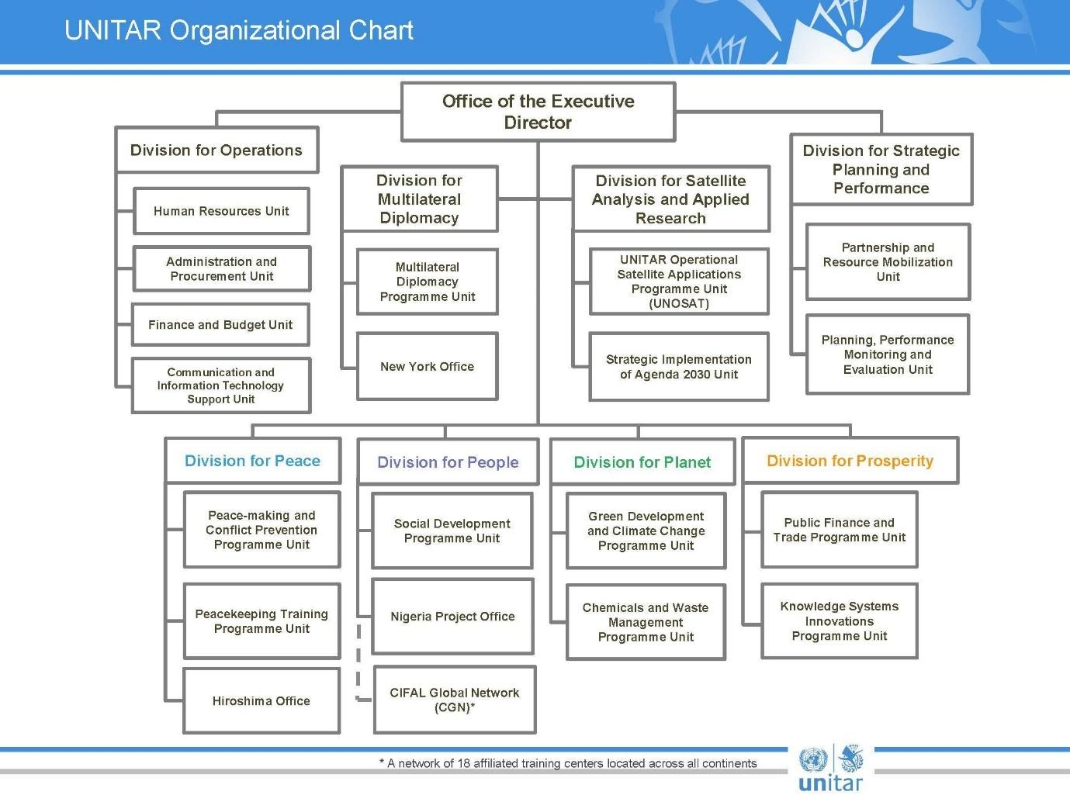

B: Event data available on the Event Management System from 1.1.2018-31.12.2019

Annex C: List of documents/data to be reviewed
- UNITAR 2018-2021 Strategic Framework https://issuu.com/unitarhq/docs/unitar_strategicframework_web
- UNITAR 2018-2019 Programme Budget https://unitar.org/about/programme-budget
- UNITAR’s 2018-2019 Programme Performance Report (when it becomes available) https://unitar.org/results-evidence-learning/results-reports-and-other-reports
- UNITAR’s 2018 and 2019 Results Reports https://unitar.org/results-evidence-learning/results-reports-and-other-reports
- UNITAR’s key performance indicators https://unitar.org/results-evidence-learning/key-performance-indicators
- UNITAR’s organizational chart (see Annex A)
- Content of UNITAR website https://www.unitar.org/
- UNITAR’s Event Management System
- Any other document deemed to be useful to the evaluation

Annex D: List of UNITAR Contact Points and Reference Group Members (to be completed)
Contacts
Division | Focal Point
Peace
People
Planet
Prosperity
Division for Satellite Analysis and Applied Research
Division for Multilateral Diplomacy
Strategic Implementation of Agenda 2030 Unit
Operations

Annex E: Structure of evaluation report

- Title page
- Executive summary
- Acronyms and abbreviations
- Introduction
- description, objectives and development context
- Theory of change/ design logic
- Methodology and limitations
- Evaluation findings based on criteria/principal evaluation questions
- Conclusions
- Recommendations
- Lessons Learned
- Annexes
  - Terms of reference
  - Survey/questionnaires deployed
  - List of persons interviewed
  - List of documents reviewed
  - Evaluation question matrix
  - Evaluation consultant agreement form

Annex F: Evaluation Audit Trail Template
(To be completed by UNITAR Management /the Reference Group to show how the received comments on the draft report have (or have not) been incorporated into the evaluation report. This audit trail should be included as an annex in the evaluation report.)

To the comments received on (date) from the mid-term evaluation of the 2018-2021 Strategic Framework

The following comments were provided in track changes to the draft evaluation report; they are referenced by institution (“Author” column) and track change comment number (“#” column):

Author | # | Para No./ comment location | Comment/Feedback on the draft evaluation report | Evaluator response and actions taken

Annex G: Evaluation Consultant Code of Conduct and Agreement Form*

The evaluator:
- Must present information that is complete and fair in its assessment of strengths and weaknesses so that decisions or actions taken are well founded.
- Must disclose the full set of evaluation findings along with information on their limitations and have this accessible to all affected by the evaluation with expressed legal rights to receive results.
- Should protect the anonymity and confidentiality of individual informants. He/she should provide maximum notice, minimize demands on time, and respect people’s right not to engage. He/she must respect people’s right to provide information in confidence and must ensure that sensitive information cannot be traced to its source. He/she are not expected to evaluate individuals and must balance an evaluation of management functions with this general principle.
- Sometimes uncovers evidence of wrongdoing while conducting evaluations. Such cases must be reported discreetly to the appropriate investigative body. He/she should consult with other relevant oversight entities when there is any doubt about if and how issues should be reported.
- Should be sensitive to beliefs, manners and customs and act with integrity and honesty in their relations with all stakeholders. In line with the UN Universal Declaration of Human Rights, he/she must be sensitive to and address issues of discrimination and gender equality. He/she should avoid offending the dignity and self-respect of those persons with whom he/she comes in contact in the course of the evaluation. Knowing that evaluation might negatively affect the interests of some stakeholders, he/she should conduct the evaluation and communicate its purpose and results in a way that clearly respects the stakeholders’ dignity and self-worth.
- Is responsible for his/her performance and his/her product(s). He/she is responsible for the clear, accurate and fair written and/or oral presentation of study imitations, findings and recommendations.
- Should reflect sound accounting procedures and be prudent in using the resources of the evaluation.
Evaluation Consultant Agreement Form
Agreement to abide by the Code of Conduct for Evaluation in the UN System
Name of Consultant: __ _________________________________________________
Name of Consultancy Organization (where relevant): ________________________
I confirm that I have received. understood and will abide by the United Nations Code of Conduct for Evaluation. I also declare that any past experience, of myself, my immediate family or close friends or associates, does not give rise to a potential conflict of interest.
Signed at place on date
Signature: ________________________________________
*This form is required to be signed by each evaluator involved in the evaluation.

www.unevaluation.org/unegcodeofconduct

